**Visualizing Sustainability: A Cognos-Based Analysis of Global Trends**

**(2000-2023)**

**Project Report**

* 1. **Introduction:**
  2. **Overview:**

The Sustainable Development Report (SDR) reviews progress made each year on the Sustainable Development Goals since their adoption by the 193 UN Member States in 2015. At the halfway mark to 2030, the Sustainable Development Report 2023 takes stock of progress made and discusses priorities to restore and accelerate SDG progress. Published on the eve of the 2023 Paris Summit for a New Global Financial Pact, this year’s edition focuses specifically on the need to scale up development finance and to reform the global financial architecture to support the SDGs.

The Sustainable Development Goals (SDGs) were approved in September 2015 by the 193 UN Member States and are also known as Agenda 2030. The framework consists of 17 goals for environmental sustainability, social inclusion, economic development, peace, justice, good governance and partnership, the main issues for the world population in the 21st century. Each goal has several targets that better define its aims. The total number of targets is 169.

The SDGs replace the Millennium Development Goals (MDGs) which expired in 2015 and were implemented over 15 years. The MDG experience underscored the importance of updated datasets for achieving the goals. Indicators are the backbone for monitoring progress towards the SDGs at local, national, regional, and global levels. Sound indicators can make the SDGs and their targets an instrument that helps countries highlight their strengths and weaknesses and monitor their progress after implementation of policies. Goals and targets are interdependent and must be pursued together as far as possible.

**1.2 Purpose:**

The SDGs were adopted by the 193 UN Member States in 2015 as a universal call to action to end poverty, protect the planet, and ensure prosperity for all. These goals are integrated and indivisible, balancing the three dimensions of sustainable development: economic, social, and environmental.

The Sustainable Development Report is typically an annual publication that assesses the progress of countries in achieving the SDGs. It provides a comprehensive review of the status of each goal, identifies challenges, and highlights successful strategies. The report often includes data, indicators, and analysis to measure progress.

In terms of visualization, various tools and techniques are employed to make the information accessible and understandable. Some common approaches include:

**Dashboards and Interactive Maps:** These tools allow users to explore data on SDG indicators for different countries and regions. Interactive maps and dashboards provide a visual representation of progress and challenges.

**Info graphics and Data Visualization:** Visual representations, such as infographics, charts, and graphs, are used to convey key information succinctly. These visuals make it easier for a wide audience to understand complex data.

**Case Studies and Success Stories:** Real-world examples and success stories are often included to showcase effective strategies and initiatives. This helps inspire and guide policymakers, businesses, and communities in their efforts to achieve sustainability.

**Global and Regional Comparisons:** Comparative analysis between countries and regions is crucial for understanding disparities and identifying areas for improvement. Visualizing these comparisons aids in setting priorities and sharing best practices.

**Online Platforms and Reports:** The SDG progress reports are often available on online platforms with interactive features, allowing users to explore data, download reports, and engage with the information.

* 1. **Literature Survey**

**2.1 Existing Problem**

The Sustainable Development Goals (SDGs) are the global milestones set by the world leaders collectively in 2015 aiming for laying a solid foundation by 2030 for achieving long-term sustainable development. However, a couple of reviews on the SDG progress in [Asia](https://www.sciencedirect.com/topics/earth-and-planetary-sciences/asia) have indicated that many countries will not achieve the 2030 targets for most of the SDGs1 (ESCAP, 2020). The United Nations, through the Decade of Action, has called for efforts to accelerate the delivery of SDGs. This, however, has been interrupted by the ongoing COVID-19 pandemic. The pandemic, which has evolved into a global crisis impacting people’s lives and disrupting the operation of businesses and the functions of the society, will affect the trajectories of SDGs by widening the existing gaps in achieving the 2030 targets (United Nations, 2020g). These include not only the SDGs hit directly by the pandemic, such as Goal 1 (poverty eradication), Goal 3 (health and well-being), Goal 4 (universal access to quality education), Goals 8 (economic growth and decent works), Goal 9 (resilient infrastructure and sustainable industrialization), and international trade (Goal 17), but also their derived impacts, such as the life-long impacts on income and development of those who will be dropped out of school permanently due to forced school closure during the lockdown.

**2.2 Proposed Solution:**

In 2015, the 193 countries that make up the United Nations (UN) agreed to adopt the 2030 Agenda for Sustainable Development. The historic agenda lays out 17 Sustainable Development Goals (SDGs) and targets for dignity, peace, and prosperity for the planet and humankind, to be completed by the year 2030. The agenda targets multiple areas for action, such as poverty and sanitation, and plans to build up local economies while addressing people's social needs.In short, the 17 SDGs are:

Goal 1: No Poverty: End poverty in all its forms everywhere.

Goal 2: Zero Hunger: End hunger, achieve food security and improved nutrition and promote sustainable agriculture.

Goal 3: Good Health and Well-being: Ensure healthy lives and promote well-being for all at all ages.

Goal 4: Quality Education: Ensure inclusive and equitable quality education and promote lifelong learning opportunities for all.

Goal 5: Gender Equality: Achieve gender equality and empower all women and girls.

Goal 6: Clean Water and Sanitation: Ensure availability and sustainable management of water and sanitation for all.

Goal 7: Affordable and Clean Energy: Ensure access to affordable, reliable, sustainable and modern energy for all.

Goal 8: Decent Work and Economic Growth: Promote sustained, inclusive and sustainable economic growth, full and productive employment and decent work for all.

Goal 9: Industry, Innovation, and Infrastructure: Build resilient infrastructure, promote inclusive and sustainable industrialization, and foster innovation.

Goal 10: Reduced Inequality: Reduce inequality within and among countries.

Goal 11: Sustainable Cities and Communities: Make cities and human settlements inclusive, safe, resilient, and sustainable.

Goal 12: Responsible Consumption and Production: Ensure sustainable consumption and production patterns.

Goal 13: Climate Action: Take urgent action to combat climate change and its impacts.

Goal 14: Life Below Water: Conserve and sustainably use the oceans, seas, and marine resources for sustainable development.

Goal 15: Life on Land: Protect, restore, and promote sustainable use of terrestrial ecosystems, sustainably manage forests, combat desertification, and halt and reverse land degradation and halt biodiversity loss.

Goal 16: Peace, Justice, and Strong Institutions: Promote peaceful and inclusive societies for sustainable development, provide access to justice for all and build effective, accountable, and inclusive institutions at all levels.

Goal 17: Partnerships to Achieve the Goal: Strengthen the means of implementation and revitalize the global partnership for sustainable development.

The SDGs build on over a decade of work by participating countries. In essence, the SDGs are a continuation of the eight Millennium Development Goals (MDGs), which began in the year 2000 and ended in 2015. The MDGs helped to lift nearly one billion people out of extreme poverty, combat hunger, and allow more girls to attend school. The MDGs, specifically goal seven, helped to protect the planet by practically eliminating global consumption of ozone-depleting substances; planting trees to offset the loss of forests; and increasing the percent of total land and coastal marine areas worldwide. The SDGs carry on the momentum generated by the MDGs with an ambitious post-2015 development agenda that may cost over $4 trillion each year. The SDGs were a result of the 2012 Rio+20 Earth Summit, which demanded the creation of an open working group to develop a draft agenda for 2015 and onward.

* 1. **Theoritcal Analysis**

**3.1 Block Diagram**

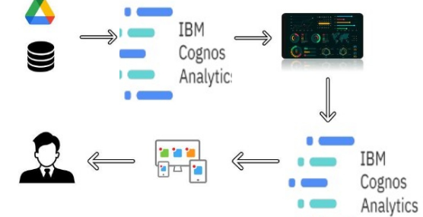

***Figure 3.1***

* 1. **Hardware / Software designing**

To accomplish this, we have to complete all the activities listed below,

**Define Problem / Problem Understanding**

* Specify the business problem
* Business requirements
* Literature Survey
* Social or Business Impact.

**Data Collection & Extraction from Database**

* Collect the dataset,
* Connect IBM DB2 with IBM cognos

**Data Preparation**

* Prepare the Data for Visualization

**Data Visualizations**

* No of Unique Visualizations

**Dashboard**

* Responsive and Design of Dashboard

**Story**

* No of Scenes of Story

**Report**

* Creating a report
  1. **EXPERIMENTAL INVESTIGATIONS**
  2. **FLOWCHART**

***Figure* *5.1 Cognos Data Analytics Flowchart***

* 1. **RESULT**

**6.1 Data Modules**

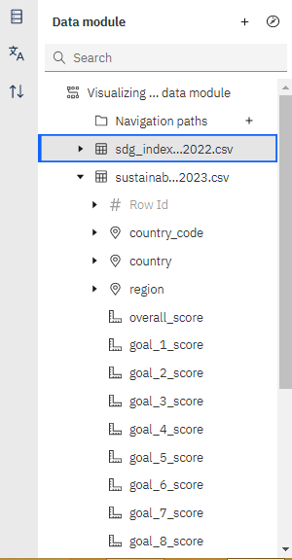 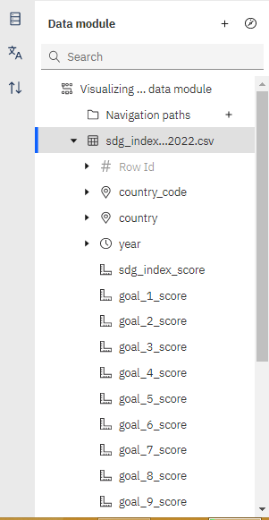

***Figure* *6.1 Visualizing Sustainability data module***

**6.2 Dashboards**

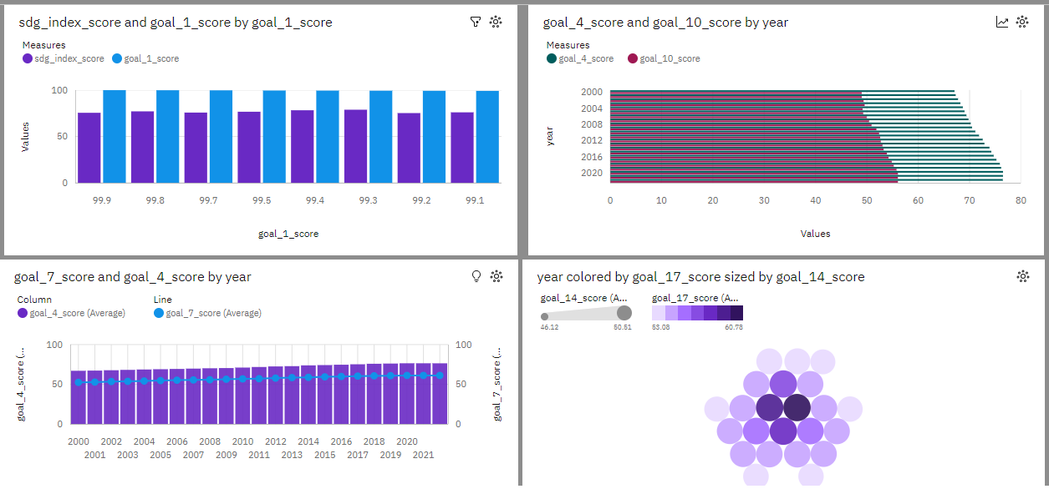

***Figure* *6.2 Visualizing Sustainability dash board Tab1***

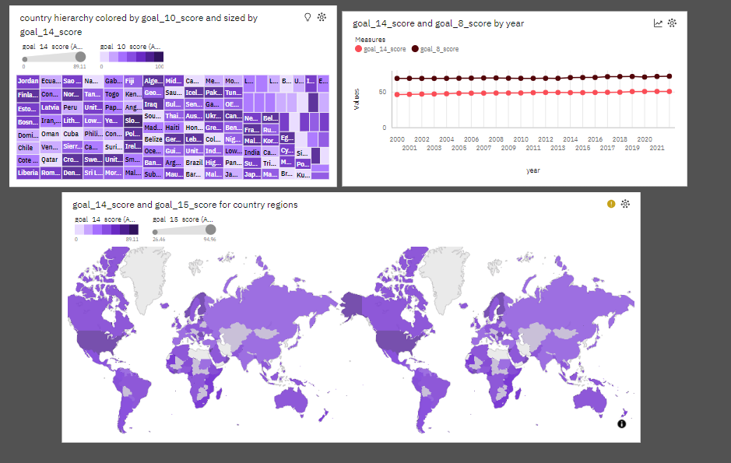

***Figure* *6.3 Visualizing Sustainability dash board Tab2***

**6.3 Report**

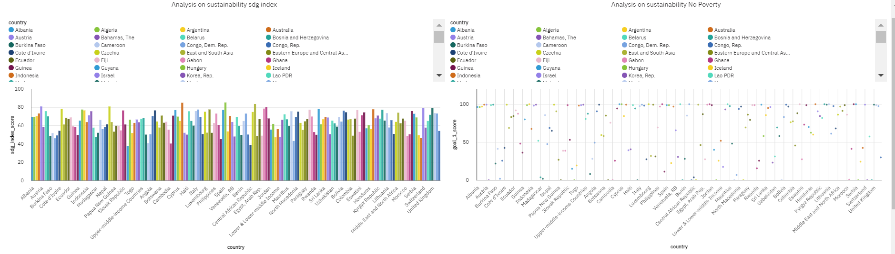

***Figure* *6.4 Visualizing Sustainability Report PageUp***

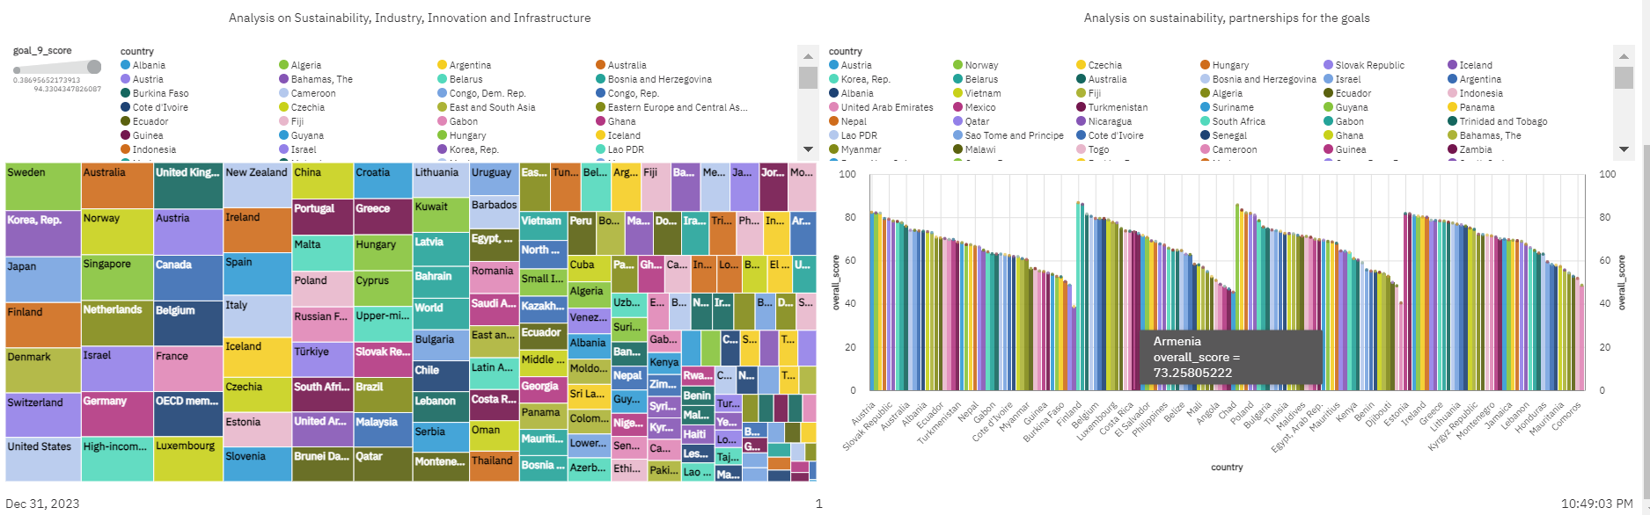

***Figure* *6.5 Visualizing Sustainability Report PageDown***

**6.4 Story**

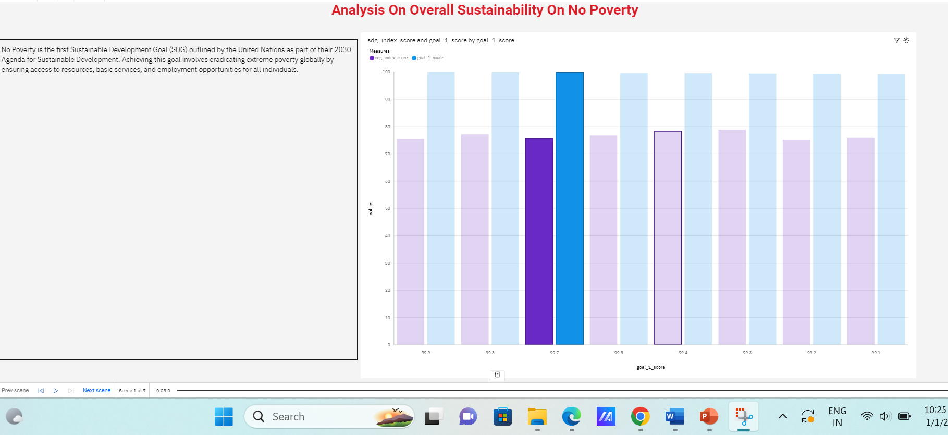

***Figure* *6.6 Visualizing Sustainability Story Scene1***

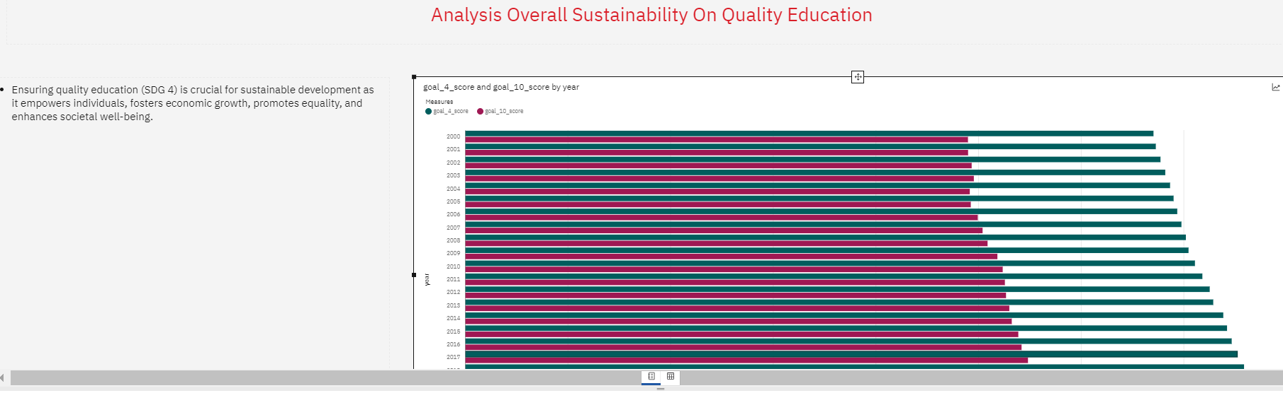

***Figure* *6.7 Visualizing Sustainability Story Scene2***

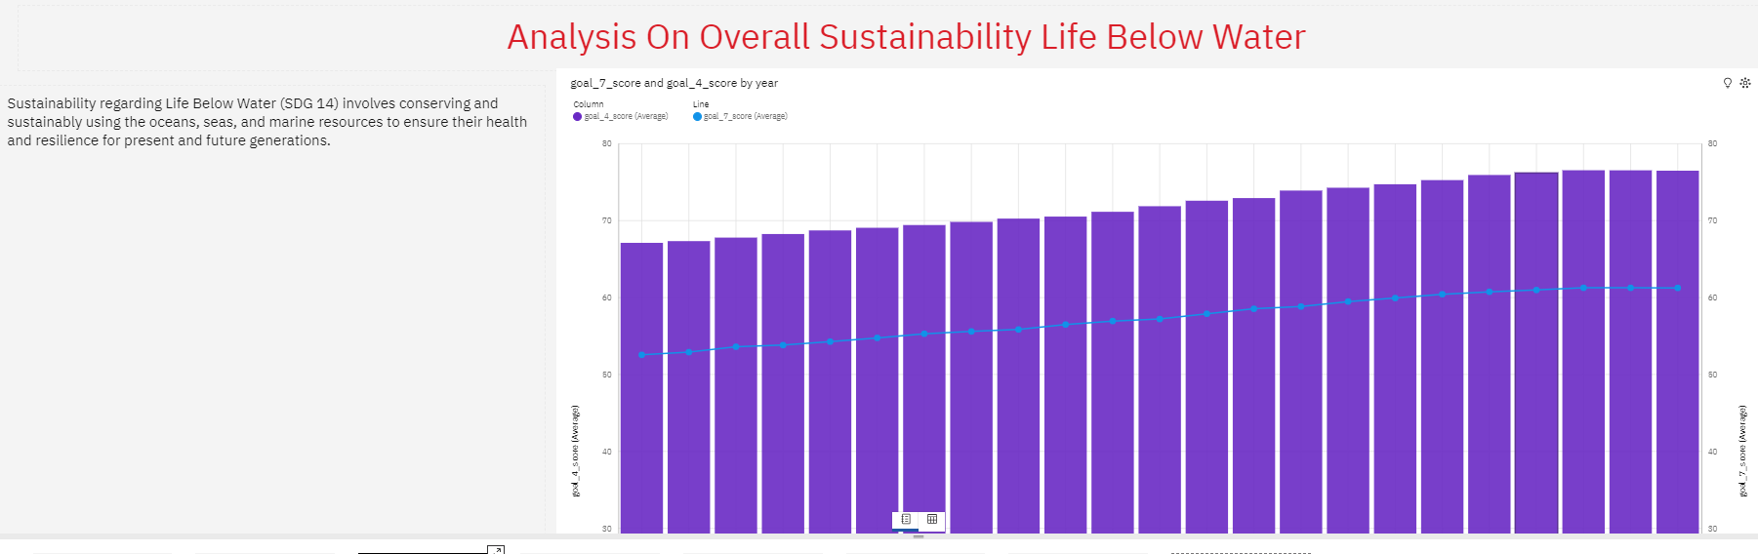

***Figure* *6.8 Visualizing Sustainability Story Scene3***

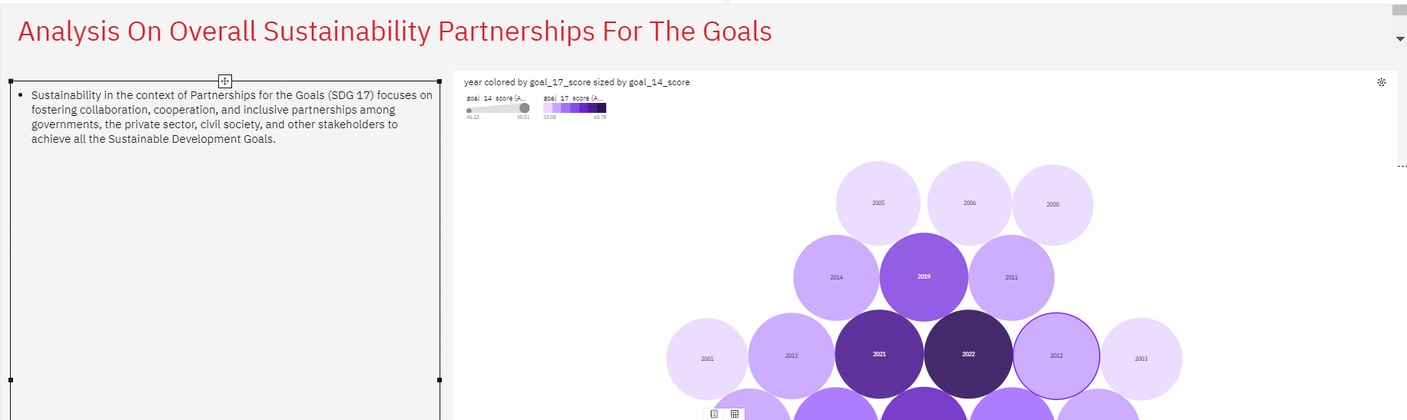

***Figure* *6.9 Visualizing Sustainability Story Scene4***

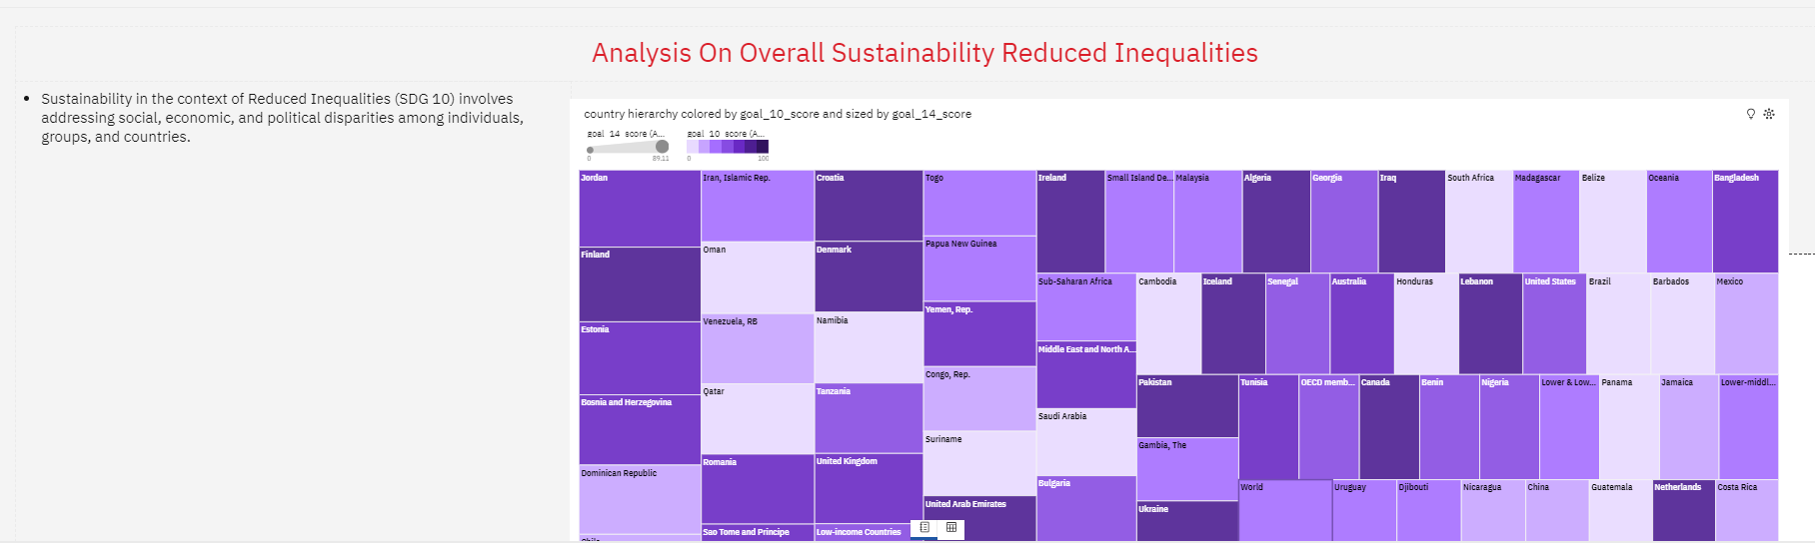

***Figure* *6.10 Visualizing Sustainability Story Scene5***

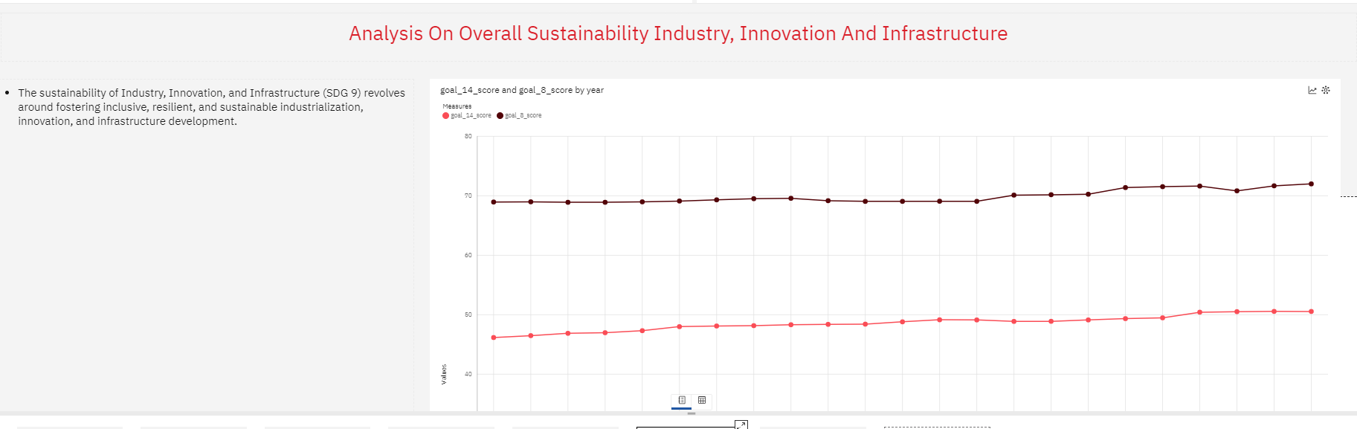

***Figure* *6.11 Visualizing Sustainability Story Scene6***

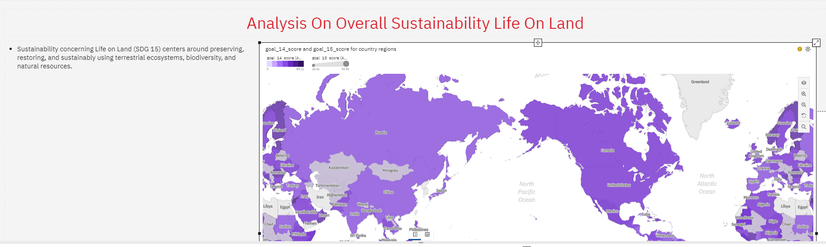

***Figure* *6.12 Visualizing Sustainability Story Scene7***

* 1. **ADVANTAGES & DISADVANTAGES**

**7.1 Advantages**

The advantages span across various dimensions, including social, economic, environmental, and political aspects. Here are some key advantages associated with the SDGs:

**Global Framework for Action:** The SDGs provide a universal and comprehensive framework that addresses a wide range of interconnected global challenges. They serve as a common roadmap for countries, organizations, and individuals to work together towards a sustainable future.

**Holistic Approach to Development:** The SDGs take a holistic approach by addressing economic, social, and environmental dimensions of development. This integrated approach recognizes the interconnectedness of different issues and encourages comprehensive solutions.

**Inclusivity and Leave No One Behind:** One of the key principles of the SDGs is to "leave no one behind." This commitment emphasizes inclusivity, ensuring that all people, regardless of their socio-economic status, gender, age, or location, benefit from development efforts.

**Alignment with National Priorities:** Countries have the flexibility to align the SDGs with their national priorities and development plans. This allows for the customization of strategies to address specific challenges and leverage opportunities based on each country's unique context.

**Global Partnerships and Collaboration:** The SDGs emphasize the importance of collaboration and partnerships among governments, private sector, civil society, and international organizations. This multi-stakeholder approach fosters collective action and shared responsibility for sustainable development.

**Data for Decision-Making:** The SDGs promote the collection and analysis of data to monitor progress and inform decision-making. This emphasis on data-driven policies enhances accountability and enables evidence-based planning and interventions.

**Poverty Reduction and Social Inclusion:** Goal 1 of the SDGs focuses on eradicating poverty in all its forms. The SDGs aim to lift people out of poverty, improve access to education and healthcare, and promote social inclusion and equality.

**Environmental Sustainability:** Several SDGs address environmental issues, emphasizing the need for sustainable consumption, climate action, and the protection of biodiversity. This contributes to efforts to combat climate change and promote responsible environmental stewardship.

**Promotion of Gender Equality:**Goal 5 emphasizes the achievement of gender equality and empowerment of all women and girls. The SDGs recognize the importance of addressing gender disparities across various sectors, promoting women's rights, and ensuring equal opportunities.

**Health and Well-being:** The SDGs include specific goals related to health and well-being (Goal 3), aiming to ensure healthy lives and promote well-being for all at all ages. This includes efforts to combat diseases, improve maternal and child health, and strengthen healthcare systems.

**Peaceful and Inclusive Societies:** Goals 16 and 17 focus on promoting peaceful and inclusive societies and building effective, accountable, and inclusive institutions. This contributes to fostering stable and just societies that uphold the rule of law.

**Long-Term Vision and Legacy:** The SDGs provide a long-term vision for sustainable development beyond 2015. They serve as a legacy for future generations, guiding ongoing efforts to address emerging challenges and advance the well-being of people and the planet.

**7.2 Disadvantages:**

Here are some of the disadvantages associated with the SDGs:

**Complexity and Interconnectedness:** The interconnected nature of the SDGs can lead to complexity and challenges in implementation. Achieving progress in one goal may be contingent on progress in others, making it difficult to prioritize and allocate resources effectively.

**Lack of Clear Accountability Mechanisms:** The SDGs lack a strong, enforceable accountability mechanism, making it challenging to hold countries accountable for their commitments. Monitoring and enforcement mechanisms are often weaker than the goals themselves.

**Resource Constraints:** Many countries, particularly those with limited resources, face challenges in mobilizing the financial, technological, and human resources required to implement the SDGs comprehensively.

**Data Limitations:** Insufficient and unreliable data for monitoring progress on the SDGs pose a significant challenge. Some countries lack the capacity to collect and analyze data, hindering the ability to track and assess their performance.

**Inequalities and Vulnerabilities:** The SDGs aim to "leave no one behind," but inequalities persist within and among countries. Vulnerable and marginalized groups may face difficulties accessing resources and benefits, exacerbating existing disparities.

**Short-Term Political Horizons:** Political cycles often operate on short-term timelines, which may conflict with the long-term vision of the SDGs. Political priorities may shift before the goals are fully realized, leading to discontinuity in implementation efforts.

**Conflicting Interests:** Balancing economic development with environmental sustainability can be challenging, as some economic activities may have negative environmental impacts. Conflicting interests among stakeholders can impede progress on certain goals.

**Resistance to Change:** Some sectors and industries may resist changes required for sustainable development due to economic interests or existing structures. Overcoming resistance and promoting transformative change can be difficult.

**Global Governance and Coordination:** Effective global governance and coordination are essential for addressing transboundary issues such as climate change and biodiversity loss. However, the lack of a strong global governance structure can hinder collective action.

**Political Will and Leadership:** The success of the SDGs depends significantly on political will and leadership at the national and global levels. Lack of commitment from governments and leaders can impede progress.

**Natural and Human-made Disasters:** Natural disasters, conflicts, and other unforeseen events can divert resources away from sustainable development efforts, slowing progress and exacerbating vulnerabilities.

**Communication and Awareness:** Insufficient public awareness and communication about the SDGs may limit their effectiveness. Building public support and engagement is crucial for successful implementation.

* 1. **APPLICATIONS**

Here are some notable applications and use cases:

**Data Platforms and Dashboards:** World Bank Data Portal: The World Bank provides an extensive data portal that allows users to explore and visualize data related to the SDGs. This includes indicators on poverty, education, health, and other key dimensions.

**Mobile Apps for Awareness and Education:** SDG in Action App: Launched by the United Nations, this app provides information about the SDGs, success stories, and actions that individuals can take to contribute to the goals. It aims to raise awareness and promote individual engagement.

**GIS and Mapping Tools:** Esri's SDGs Maps: Geographic Information System (GIS) technology is used to create interactive maps that visualize spatial data related to the SDGs. These maps help in understanding regional disparities and planning interventions.

**Blockchain for Transparency:** Blockchain for Supply Chain Traceability: Blockchain technology is applied to enhance transparency in supply chains, ensuring that products are produced sustainably and meet ethical standards, contributing to goals such as responsible consumption (SDG 12).

**AI and Predictive Analytics:** Predictive Analytics for Disease Prevention: Artificial intelligence (AI) is used to analyze health data and predict disease outbreaks. This application supports efforts related to SDG 3 (Good Health and Well-being) by improving disease prevention and response.

**E-Learning Platforms:** Online Education Platforms: Various e-learning platforms offer courses on sustainable development, enabling individuals to acquire knowledge and skills related to the SDGs. These courses cover topics such as environmental conservation, poverty reduction, and social equality.

**Crowd sourcing and Citizen Engagement:** U-Report by UNICEF: This mobile-based application allows users to participate in polls and surveys on issues related to the SDGs. It facilitates citizen engagement and gathers real-time data for decision-making.

**Financial Inclusion Apps:** Mobile Banking Apps: Financial inclusion apps contribute to SDG 1 (No Poverty) by providing access to banking services, empowering individuals economically, and reducing poverty.

**Renewable Energy Monitoring:** Renewable Energy Monitoring Platforms: IoT (Internet of Things) devices and platforms are used to monitor renewable energy sources, contributing to goals such as affordable and clean energy (SDG 7).

**Climate Action Apps:** Climate Action Apps: Various apps provide information and tools for individuals and communities to take action on climate change, aligning with SDG 13 (Climate Action).

**Corporate Sustainability Reporting Software:** Sustainability Reporting Platforms: Many businesses use software tools to report on their sustainability practices, aligning with SDG 12 (Responsible Consumption and Production) and promoting corporate social responsibility.

**Open Data Initiatives:** Global Database on Disability: Open data initiatives provide information on specific issues, such as disability statistics, contributing to efforts related to SDG 10 (Reduced Inequality) and SDG 3 (Good Health and Well-being).

* 1. **CONCLUSION**

The adoption of the Sustainable Development Goals (SDGs) by the 193 UN Member States in 2015 marked a significant milestone in global efforts toward achieving a more sustainable and equitable world. Over the years, progress has been made in various areas, with governments, businesses, civil society, and individuals contributing to the pursuit of these goals. The SDGs provide a comprehensive framework that addresses interconnected challenges, ranging from poverty and inequality to environmental sustainability and peace.

However, challenges persist, and the journey toward achieving the SDGs is complex. Issues such as resource constraints, data limitations, and the need for enhanced global cooperation present ongoing challenges. Nevertheless, the SDGs serve as a guiding vision, encouraging countries to work collaboratively and adopt innovative approaches to overcome obstacles.

* 1. **FUTURE SCOPE**

The future will likely see increased efforts to integrate the SDGs into national policies, ensuring that sustainable development becomes a fundamental aspect of governance and decision-making. The private sector is expected to play an increasingly vital role in achieving the SDGs. Businesses are likely to incorporate sustainability into their core strategies, aligning economic growth with social and environmental responsibility. Strengthening global partnerships and collaborations is essential. Future initiatives may focus on fostering cooperation between countries, international organizations, and non-governmental entities to address trans- boundary challenges effectively.

Educational initiatives and advocacy efforts will continue to be crucial for raising awareness about the SDGs. Empowering individuals with knowledge and encouraging active participation will be essential for driving change at the grassroots level. The world is dynamic, and new challenges may emerge over time. The SDGs will need to be flexible and adaptable to address emerging issues, such as the impacts of technological advancements, global health crises, and climate change. Efforts to achieve the SDGs will benefit from inclusive decision-making processes that involve diverse stakeholders. Engaging marginalized and vulnerable groups in the planning and implementation of sustainable development initiatives will be crucial. Building resilience and preparedness for natural disasters, health emergencies, and other crises will be integral to sustaining progress toward the SDGs. This includes strengthening health systems, disaster response mechanisms, and social safety nets.

* 1. **BIBILOGRAPHY**

# Mohammadhadi Hajian, Somayeh Jangchi Kashani - Evolution of the concept of sustainability. From Brundtland Report to sustainable development goals, Sustainable Resource Management Modern Approaches and Contexts,2021, Pages 1-24. <https://doi.org/10.1016/B978-0-12-824342-8.00018-3>

# Xin Zhou, Mustafa Moinuddin, Chapter24 - Impacts and implications of the COVID-19 crisis and its recovery for achieving sustainable development goals in Asia A review from an SDG interlinkage perspective, [Environmental Resilience and Transformation in Times of COVID-19](https://www.sciencedirect.com/book/9780323855129/environmental-resilience-and-transformation-in-times-of-covid-19), 2021, <https://doi.org/10.1016/B978-0-323-85512-9.00018-8>

1. Cognos Analytics offerings - IBM Documentation
2. IBM Cognos. Scalable and flexible, but watch out...it's expensive. | TrustRadius
3. Free Skills-Based Learning From Technology Experts | IBM SkillsBuild